**What is Feature Scaling - Normalization and Standardization**

**Scaling** or **Feature Scaling** is the process of changing the scale of certain features to a common one. This is typically achieved through  **normalization** and **standardization** (scaling techniques).

* **Normalization :** is the process of scaling data into a range of [0, 1]. It's more useful and common for regression tasks.

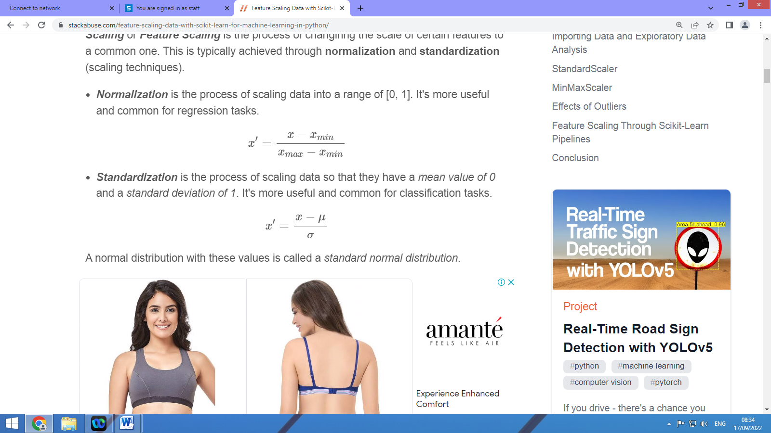

Normalization is also known as Min-Max Scaling and Scikit-Learn provides the MinMaxScaler for this purpose.

* **Standardization :** is the process of scaling data so that they have a mean value of 0 and a standard deviation of 1. It's more useful and common for classification tasks.



To perform standardization, Scikit-Learn provides us with the StandardScaler class

**Normalization :**

import pandas as pd

import numpy as np

df=pd.read_csv("D:\\vmp\\AI with Python Lab\\datascal.csv")

df.head

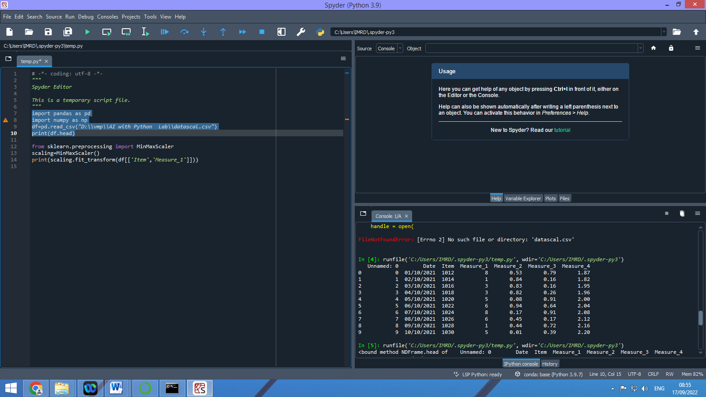

from sklearn.preprocessing import MinMaxScaler

scaling=MinMaxScaler()

scaling.fit_transform(df[['Item','Measure_1']])

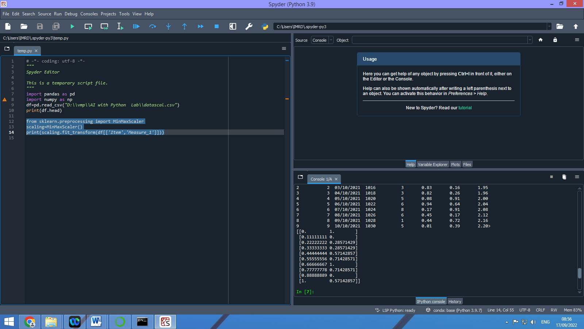

**Standardization:**

from sklearn.preprocessing import StandardScaler

scaling=StandardScaler()

scaling.fit_transform(df[['Item','Measure_1']])

